Question 1
Cournot Duopoly
Suppose that Coca Cola and Pepsi companies compete in quantity sold in a small town. The market demand function for soda in the small town is given by the demand function: Q = 10,000 - P where Q is the aggregate quantity demanded and P is the price of a can of soda. Let Qp be the number of cans of soda sold by the Pepsi company and Qc be the number sold by the Coca Cola company. Assuming that the marginal cost of producing a can of soda is the same for both companies and equal to 50 cents, find the Nash equilibrium of the soda market in this small town. Illusrate the Nash equilibrium by using the best repsonse functions of both companies.
Q = 10,000-P
P = 10,000 - qc - qp
c = (P-MC) ×qc (Profit function of Coca-Cola)
= (10,000 - qc - qp - 0.5) ×qc
c = (9999.5 - qp)qc - qc^2
dc/dqc = 0
9999.5 - qp = 2qc
qc* = 4999.75 - 0.5qp (Best response function of Coca-Cola)

qp* = 4999.75 - 0.5qc ( Best response function of Pepsi)

qc* = 4999.75 - 0.5*(4999.75 - 0.5qc)
qc = 4999.75 - 2499.875 + 0.25qc
0.75qc = 2499.875
qc = 3333.16
qp = 3333.16
Nash Equilibrium: (qc, qp) = (3333.16, 3333.16)
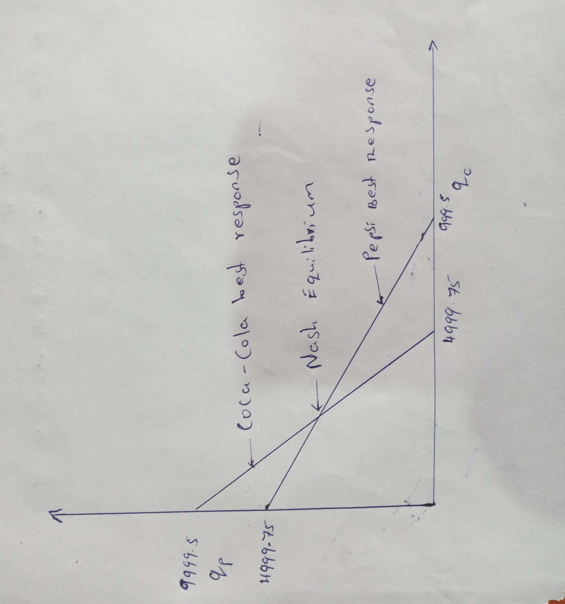

Question 2
Bertrand Duopoly
Consider the market for smart phones. Suppose that Apple and Samsung companies are the only players in this market and that the marginal cost of producing a smartphones is the same and equal to $150 for both companies. You can assume that in this question Apple and Samsung compete in their prices.

- Assuming that Apple and Samsung produce identical products (ie: no product differentiation), find the Nash equilibrium of the smart phone market. You can further assume that both companies begin competing with each other at an initial price of $1,000 per smart phone. Illustrate the best response functions of both companies and the Nash equilibrium of the market. (10 pts)
MC_{a=}MCs=$150
For identical products PA=PS=$150
therefore P_{i}>150 cannot be Nash equilibrium since they have an incentive to change the price lower than their rival
P_{i}<150 would increase the losses; therefore it is better to deviate and charge PA=PS=$150
At $1000 per smartphone PA=PS=$1000,Samsung and Apple would have an incentive slightly out beat its rival price
Therefore PA=PS= MC=$150 per smartphone is the Nash equilibrium, and both will share the market equally.

b. Now suppose that through successful advertising campaigns Apple and Samsung have able to create the impression in the minds of their customers that their products or different (or it might actually be the case that their products are different.). Suppose that the demand for Apple smartphones is given by the equation Qa = 1,000,000 - 0.4 Pa + 0.5 Ps and the demand function for Samsung smartphones is symmetrical, ie: Qs = 1,000,000 - 0.4 Ps + 0.5 Pa where Qa is the amount of Apple smartphones demanded, Qs is the amount of Samsung smartphones demanded, Pa is the price of an Apple smartphone, and Ps is the price of a Samsung smartphone. You can again assume that the marginal cost of production is the same for both companies and is equal to $150 per smartphone.
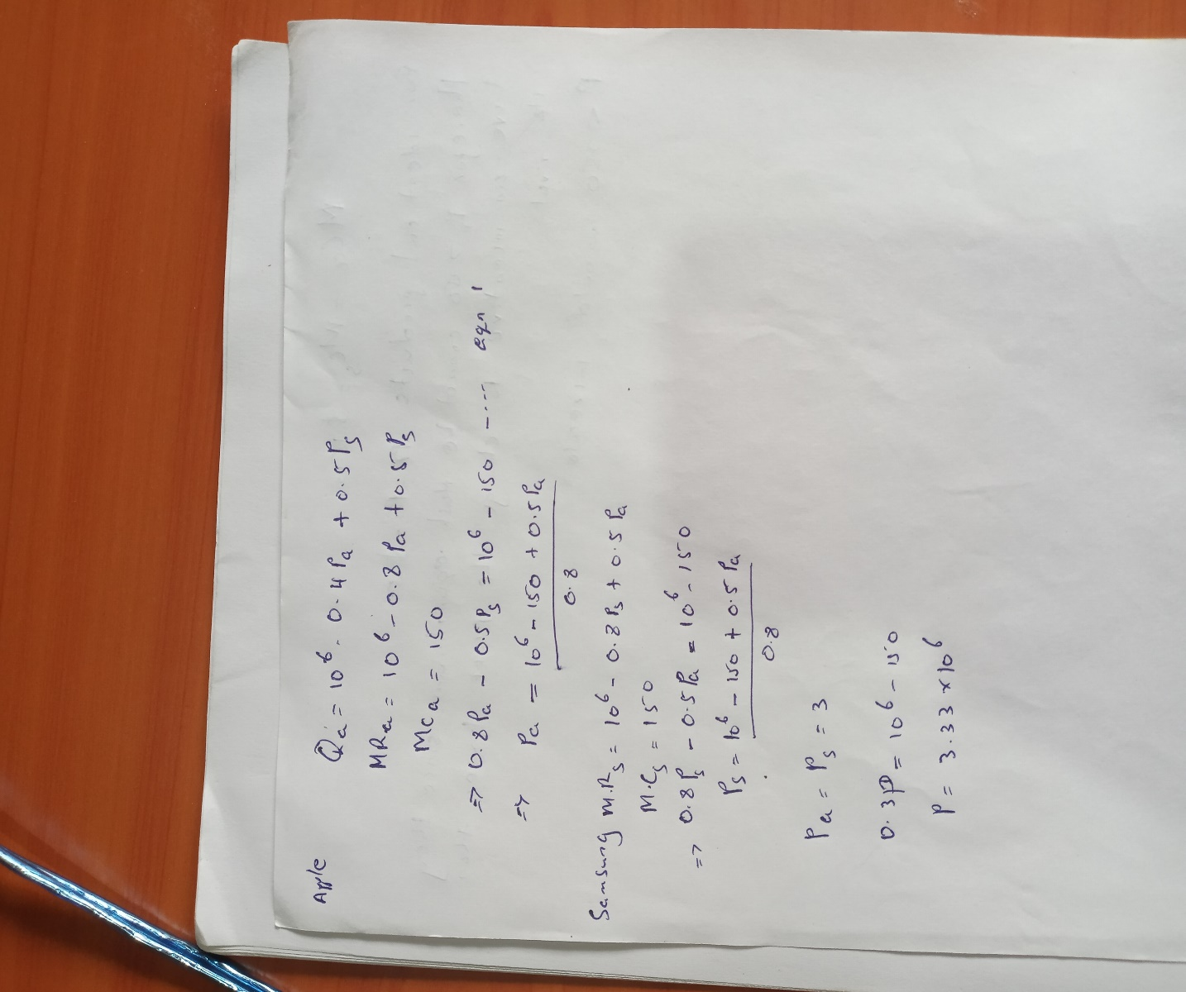

Question 3
Maintaining collusion vs competing in a Cournot duopoly

Now consider two major oil producing companies in the US: Chevron and Exxon Mobil. Suppose that the two companies compete in a Cournot Duopoly in the US and the aggregate demand function faced by the companies is given by the equation Q = 18,000,000 - P where Q is the average number of barrels of oil demanded per day in the US and P is the price of a barrel of oil. Further, you can assume that the marginal cost of extracting a barrel of oil is $36 for both companies.

- Assume that the two companies begin colluding with each other and act like a monopoly. What would be the price of a barrel of oil charged by this monopoly and how many barrels of oil would this monopoly choose to produce? (10 pts)

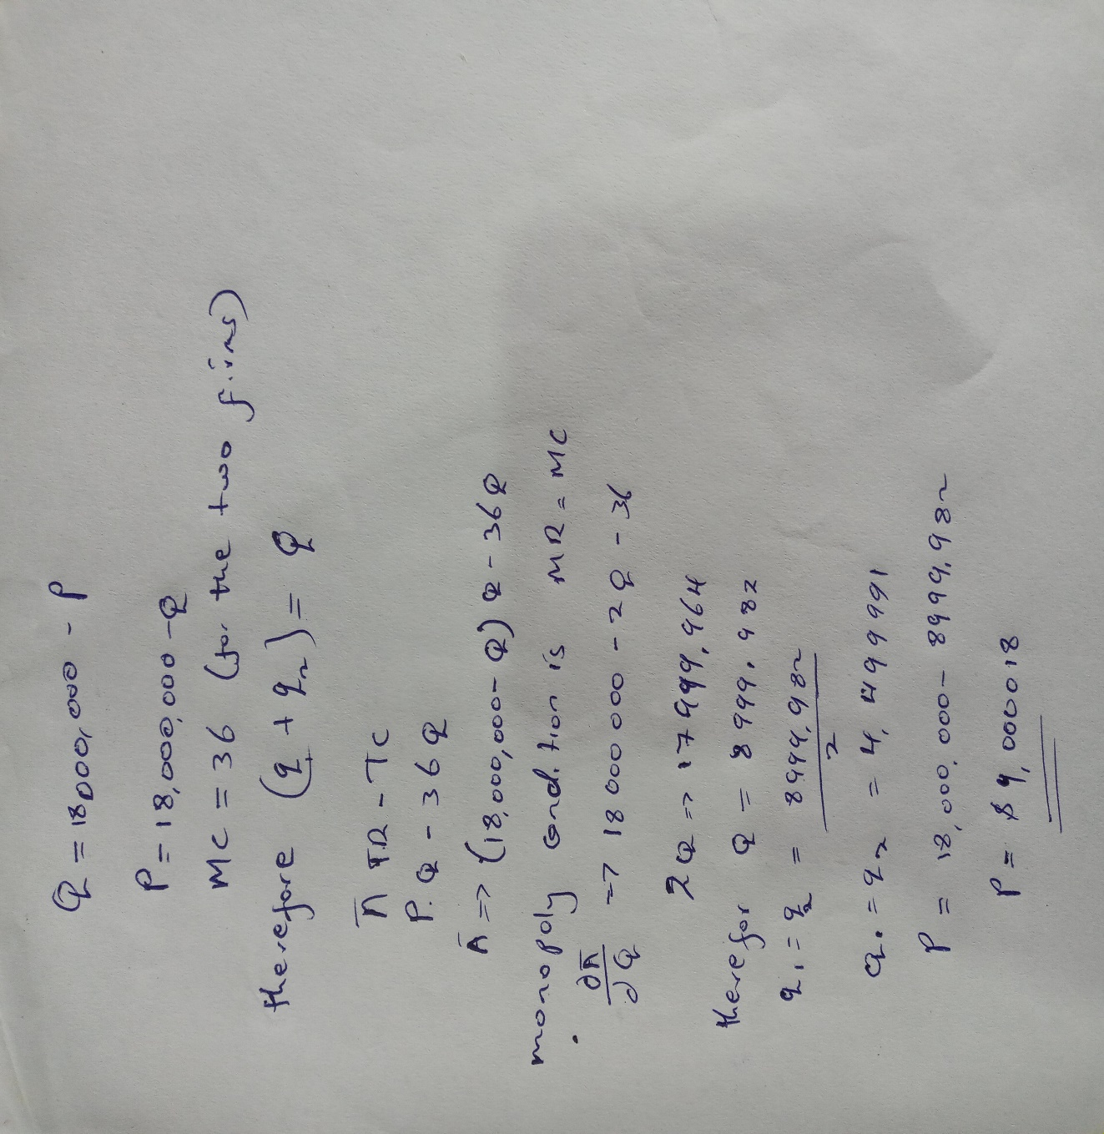
b. Now assume that the two companies find collluding with each other very difficult and so begin deviating from the collusive aggreement, ie: they stop acting like a monopoly. Find the Nash equilibrium of this duopolistic market. Make sure to illustrate the best response functions of the two companies and the Bash equilibrium for full credit. (10 pts)
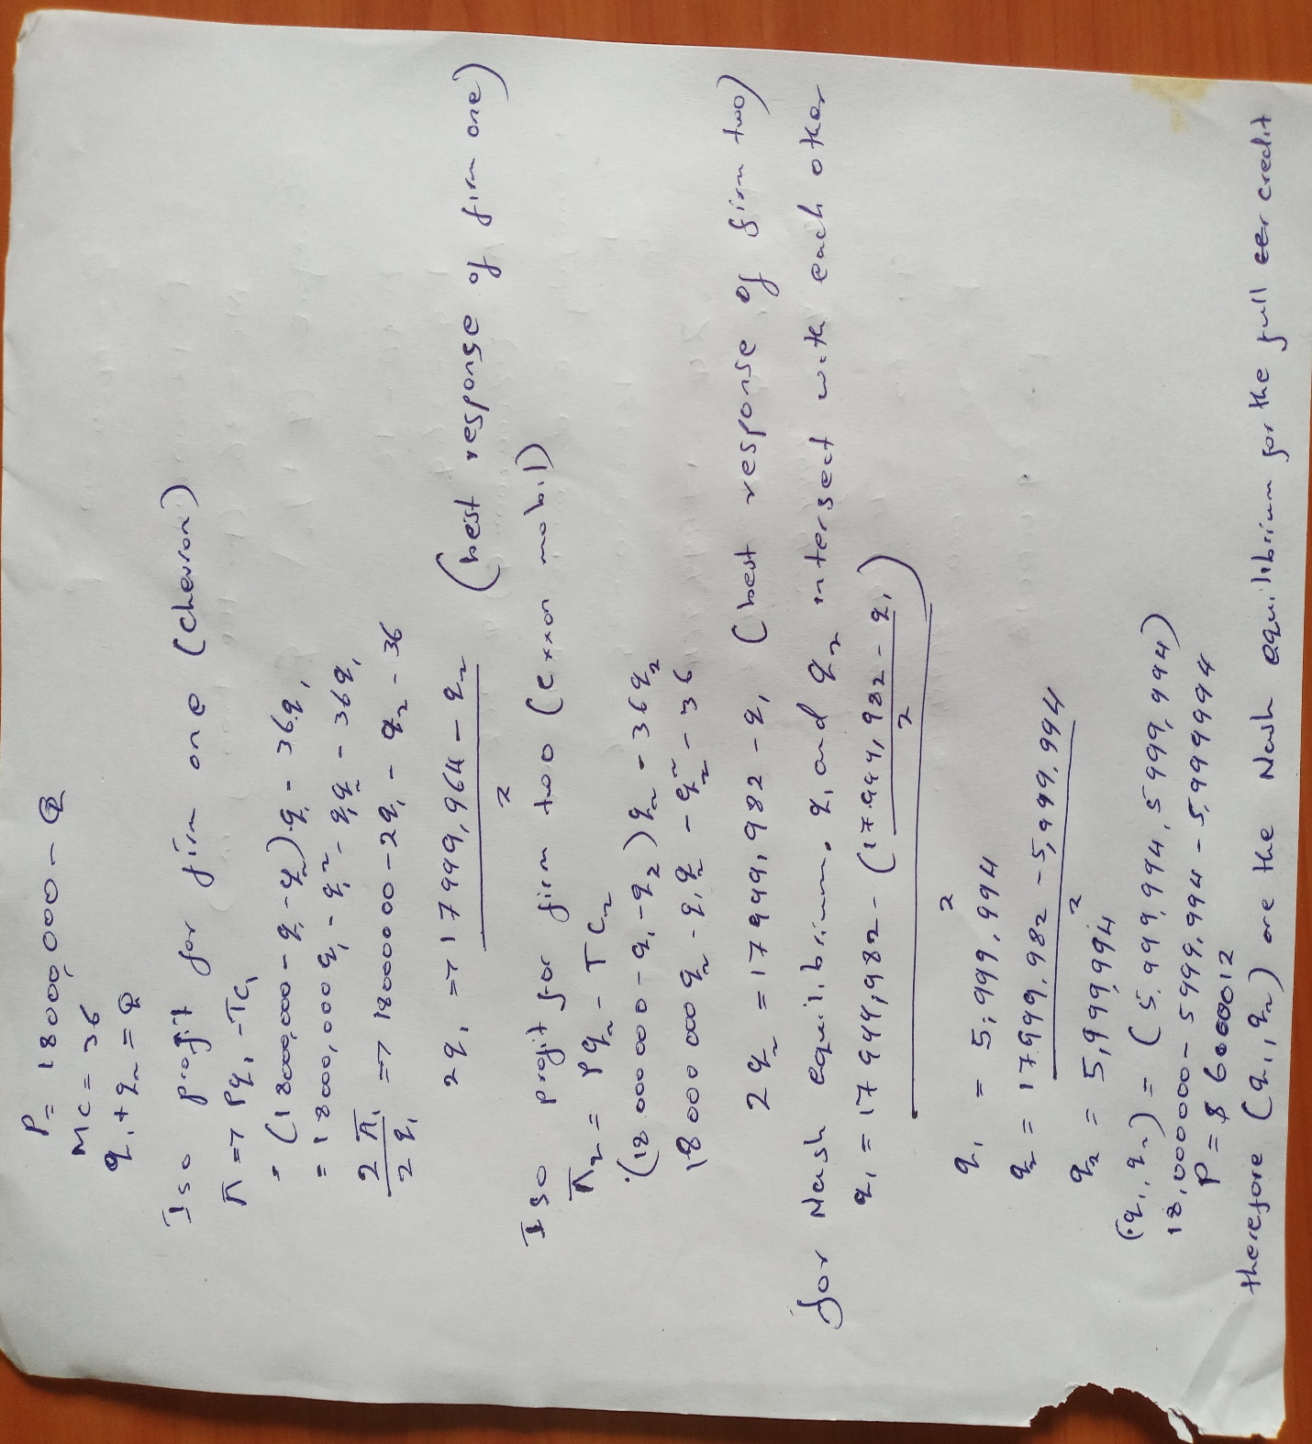

P=6000012
c. Which outcome do you think would be preferable to Exxon Mobil and Chevron, the duopolistic competition or collusive aggrement to act like a monopoly? What obstacles do the companies face when try to maintain a collusive aggrement? (5 pts)
a) P= 9000018 dollar
q1=q2= 4499991
P=6000012 dollar
q1=q2=5999994
doupolist outcome is preferable since in our case the equilibrium price is less and the quantity demanded is more. Therefore is the two firms consider a doupolist outcome the price will increase.
Question 4
Monopolistic Markets
- What are the potential reasons that would create monopolistic markets? (5 pts)
1.advantage of first entrant-a business entering a market first enjoys the competitive advantage.
2.involvement of high capital removes the interest of other firms to pursue the market gap.
3.less profit if the profit earned by a business is low other potential investors will be discouraged from entering the market.
4. copyright for manufacturing certain products limits other firms from copying the production process.
5.advantage geographic location offers the upper hand for a monopoly business to enjoy the profits.
b. What are the arguments for supporting the creation of monopolies? (5 pts)
different factors support the existence of monopolies in the market.
1.monopolies practice economies of scale since they single producers, and the clients enjoy lower production costs.
2.less competition in the market results from lack of production deafferentation for which firms can charge high prices.
3.due to the large investment by monopolies majority of firms are reluctant to invest in similar projects.

c. What are the potential counter arguments against monopolistic markets? List five different ways of making a monopolistic market more competitive. (5 pts)

1.the state should offer subsidies to such businesses if they meet the requirements.
2. monopolies should develop large-scale production and cost-effective production techniques, which will reduce the price for the buyers, and consumer welfare will increase.
3.monopolies should compete with global competitors since such practice will improve efficiency.
4.the government should remove the restriction of entry and exit of new firms in the market. By doing so, the monopolies will increase their effectiveness.
5.the government should impose strict production rules to increase monopolies competition.
Question 5
Competitive Markets

Agricultural markets are the typical example of competitive markets: millions of producers with little to no market power, no product differentiation, free entry and exit, perfect information about the identical nature of the products offered by different producers. Agricultural markets satisfy all of these criteria.

The crop seed market for commercially produced plants such as corn, cotton, soybean, canola etc. used to be close to perfectly competitive before 90s. As will be explained in the next question this market got less and less competitive since then.

For the purpose of this question, consider a seed producer in Washington State in 1985 selling corn seeds. Suppose this company is making economic losses.

- How does the price of corn seeds compare to the average total cost and the average variable cost of producing corn seeds in the short run? Draw the cost curves (average total cost, average variable cost, and the marginal cost) of this representative firm and the price of corn seeds to illustrate its situation in the short run? (10 pts)
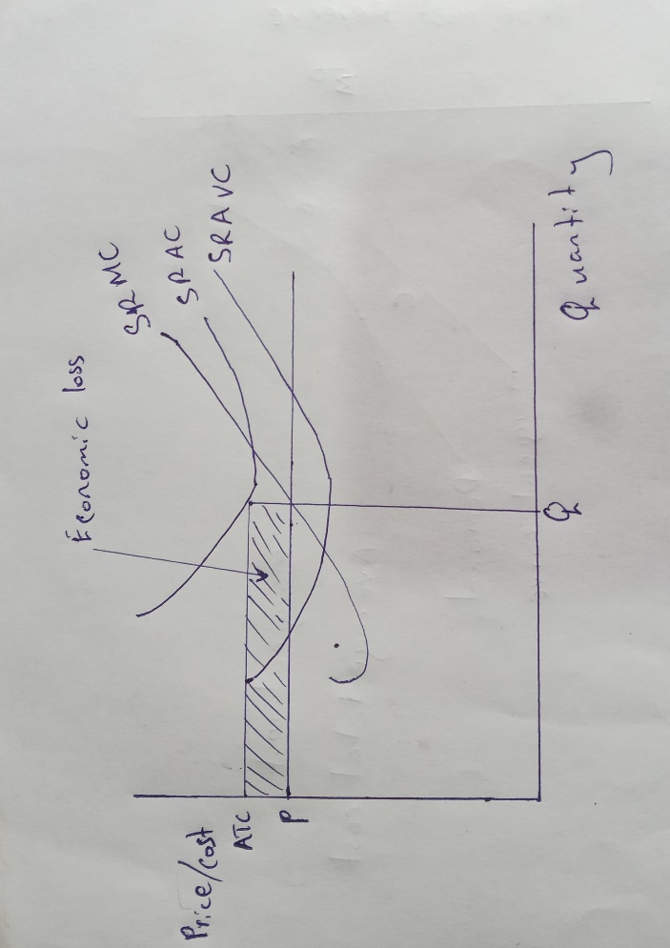
P=market price
Q=quantity supplied
The loss is AVC < P < ATC
- Now suppose there is a positive demand shock for corn (ie: demand for corn increases) and so the price of corn seeds goes up. The corn seed producer in part-a begins making an economic profit. Draw the cost curves (average total cost, average variable cost, and the marginal cost) of this representative firm and the price of corn seeds to illustrate its new situation? (5 pts)
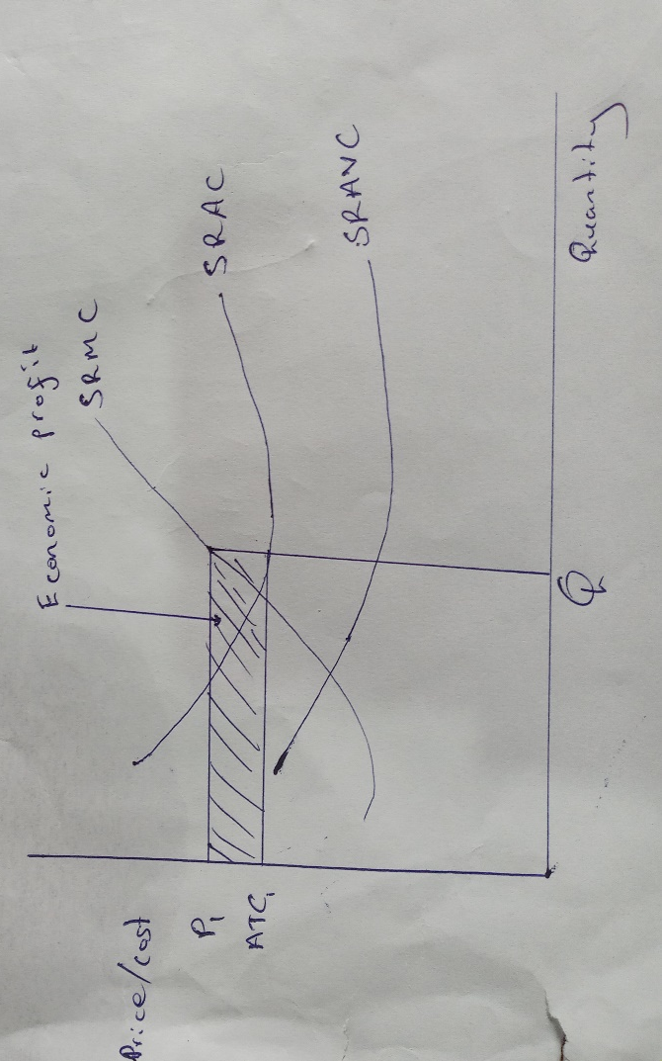
new quantity is Q₁ (Q₁ > Q)
the new market price is P₁ (P₁ > P).
the firm starts making economic profits with the condition P > ATC > AVC

c. Now that the corn seed producer from part-a is making a profit, what will happen to the corn seed market in the long run? What will happen to the economic profit of an individual corn seed producer? What will happen the quantity supplied by each firm in this market (increase, decrease or ambiguous change?) and the total quantity supplied in the market? (5 pts)
with the rising economic profits and no barriers to exit and entry, new businesses will start joining and market, thus increasing the number of suppliers. Thus, the firm will be forced to produce less, thus decreasing its profit from P₁ to ATC₁.businesses operating below this point will exit the market and have zero profits.
Question 6
BONUS QUESTION: MONOPOLISTIC COMPETITION
Sparkle is one firm of many in the market for toothpaste, which is in long-run equilibrium.
a. Draw a diagram showing Sparkle’s demand curve, marginal-revenue curve, average-total- cost curve, and marginal-cost curve. Label Sparkle’s profit-maximizing output and price. (5 pts)
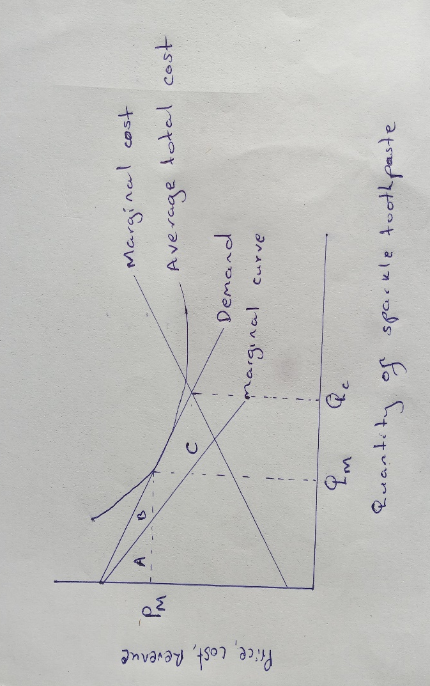
b. What is Sparkle’s profit? Explain. (5 pts)
sparkle’s profit is zero because the price equals the average total cost at quantity Q_{M}
c. On your diagram, show the consumer surplus derived from the purchase of Sparkle toothpaste. Also show the deadweight loss relative to the efficient level of output. (5 pts)
the consumer surplus from the purchase of toothpaste is A+B the efficient level of outcome occurs in the rea where the demand curve intersects the marginal cost curve at Q_{C} the dead weight area is C
d. If the government forced Sparkle to produce the efficient level of output, what would happen to the firm? What would happen to Sparkle’s customers? (5 pts)

If the government forced Sparkle to produce an efficient output level, the business would lose money since the average cost would exceed the price.

